LAPORAN LATIHAN 5

SISTEM PARALEL DAN TERDISTRIBUSI



Disusun Oleh:

|  |  |
| --- | --- |
| Aurell Layalia Safara Az-Zahra Gunawan | 1301170231 |
| Brigita Tenggehi | 1301170302 |
| Christian Hary | 1301170348 |
| Hafiyy Viazola | 1301174032 |

Kelas :

IF-41-09

PROGRAM STUDI INFORMATIKA

FAKULTAS INFORMATIKA

UNIVERSITAS TELKOM

BANDUNG

2020

Peran Anggota

|  |  |  |
| --- | --- | --- |
| Nama | NIM | Peran |
| Aurell Layalia Safara Az-Zahra Gunawan | 1301170231 | Serial Ping, Server Thread (Nomor 2), Running Program |
| Brigita Tenggehi | 1301170302 | Client Thread (Nomor 2), Laporan |
| Christian Hary | 1301170348 | Download File Comment (Nomor 3) |
| Hafiyy Viazola | 1301174032 | Paralel Ping (Nomor 1) |

Nomor 1 : Serial Ping & Paralel Ping

Hasil Serial Ping :

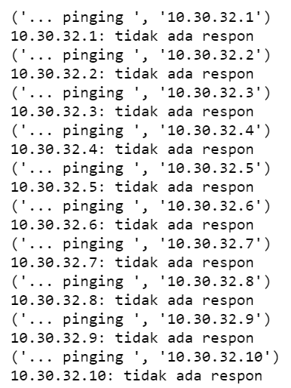 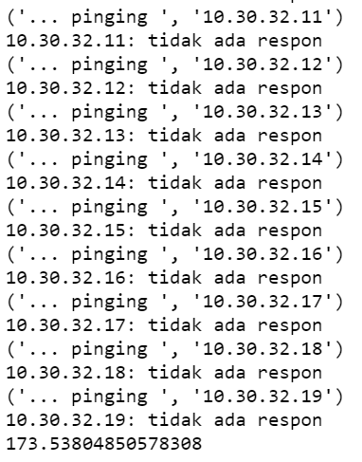

Hasil Paralel Ping :

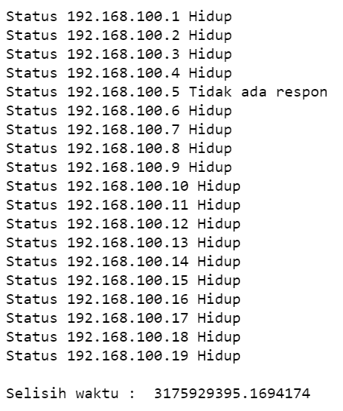

Nomor 2 : Multithreaded Server

Hasil Client Thread 1 :



Hasil Client Thread 2 :



Hasil Server Thread :



Nomor 3 : Comment Download File

Hasil Comment Download File :





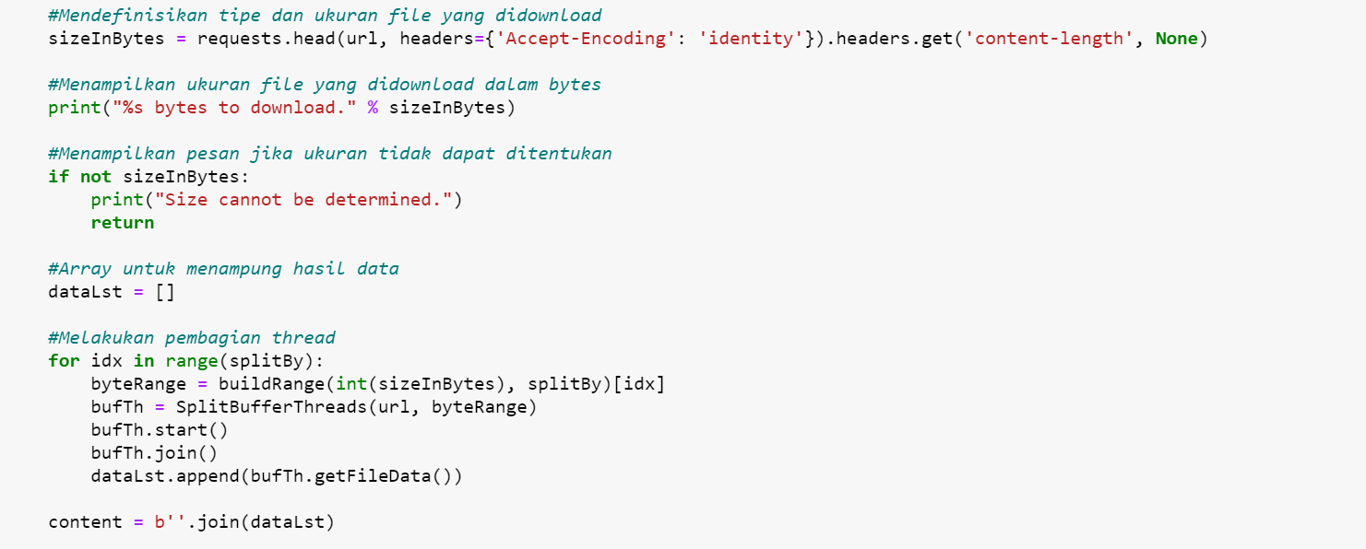



Hasil Download File :

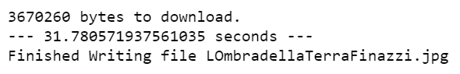

File Yang Didownload :

